21 Ans:B

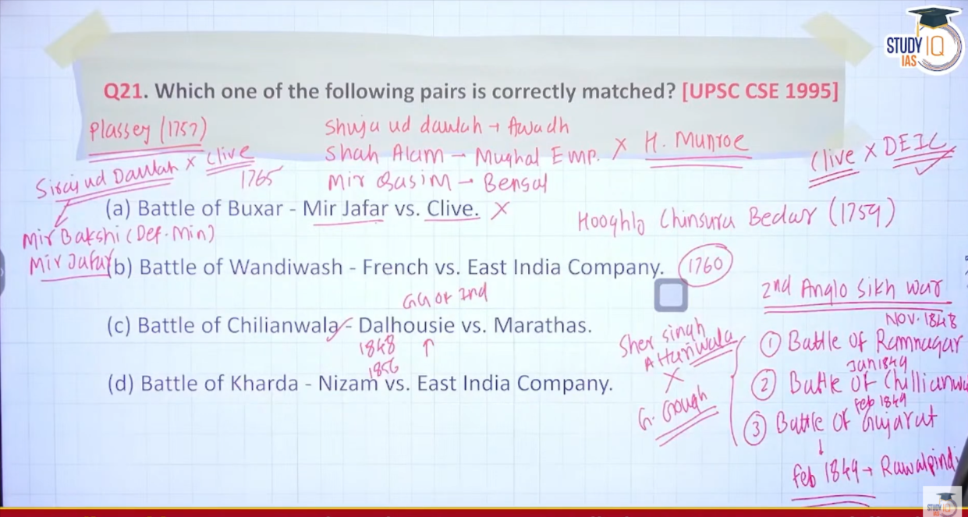

22 Ans:B
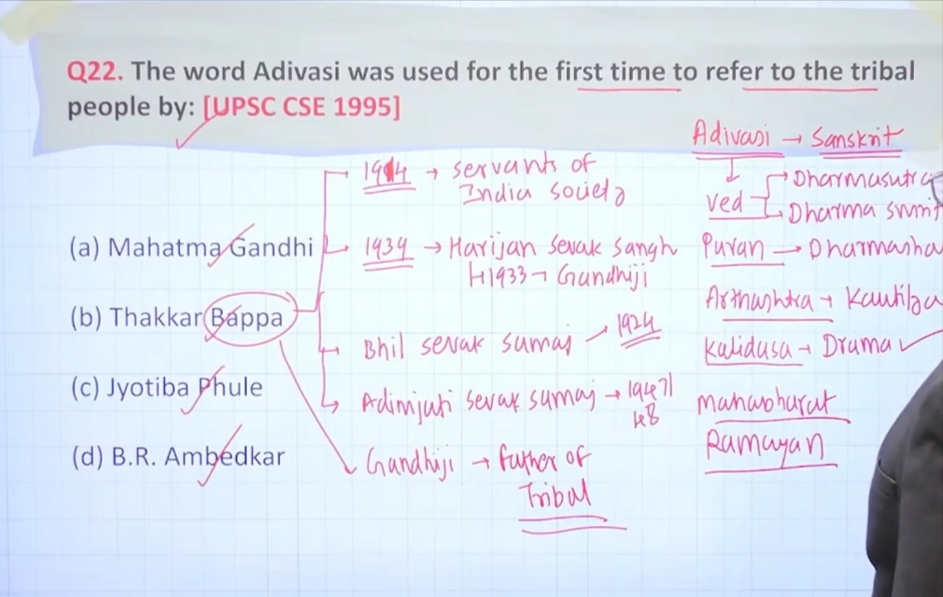

23 Ans:D

dada bhai naroji is called father of nation also inko father of nation bolne ka kaam Gandhi ji ne kyia hua hai he is best known for his drain of wealth theory
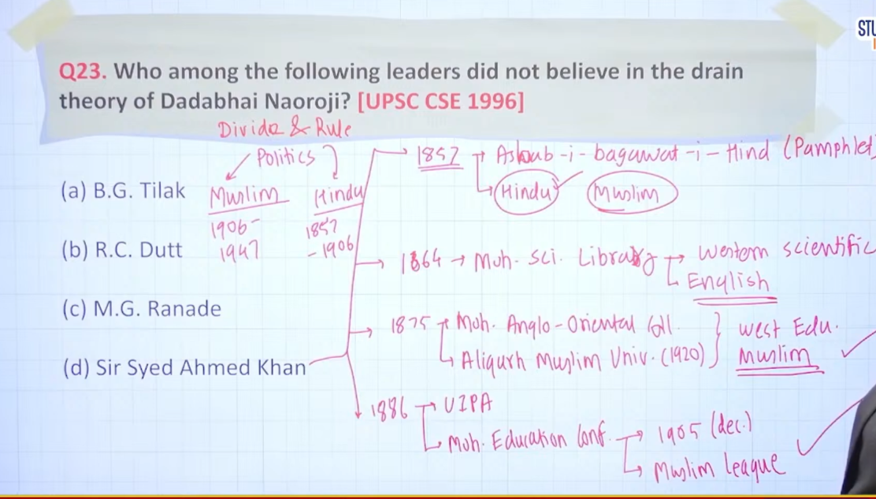

24 Ans:B
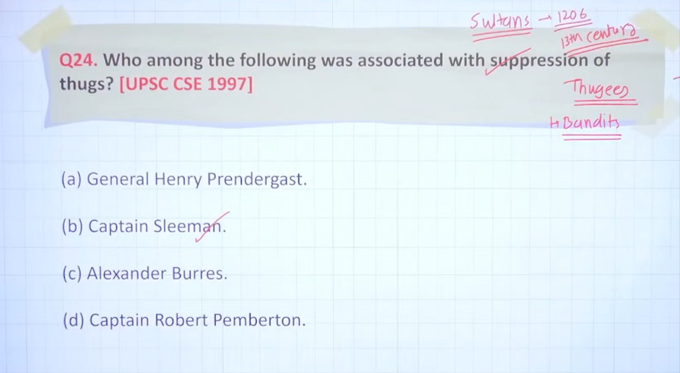
25 Ans:C
